Write the code to implement the concept of inheritance for Vehicles. You are required implement inheritance between classes. You have to write four classes in C++ i.e. one superclass, two sub classes and one driver class. Vehicle is the super class whereas Bus and Truck are sub classes of Vehicle class. Transport is a driver class which contains main method.

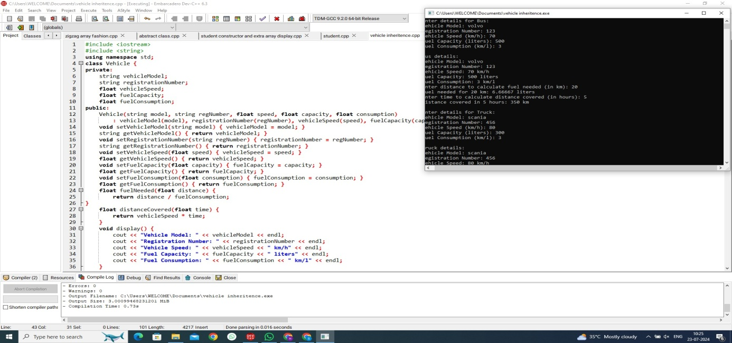

Write a program to print the names of students by creating a Student class.If no name is passed while creating an object of Student class,then the name should be "Unknown", otherwise the name should be equal to the String value passed while creating object of Student class. (Use Constructors)

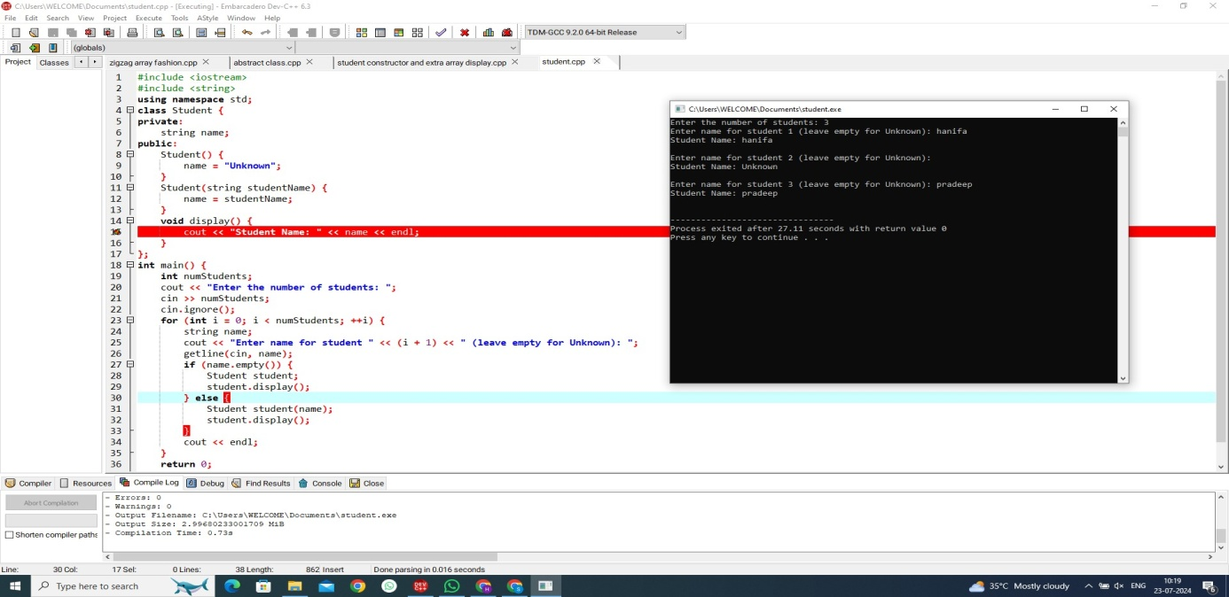

Write a user-defined Function EXTRA_ELE(int A[], int B[ ], int N) in C++ to find and display the extra element in Array A.Array A contains all the elements of array B but (Restriction: array elements are not in order) one more element extra.Example If the elements of Array A is 14, 21, 5, 19, 8, 4, 23, 11 and the elements of Array B is 23, 8, 19, 4, 14, 11, 5 Then output will be 21

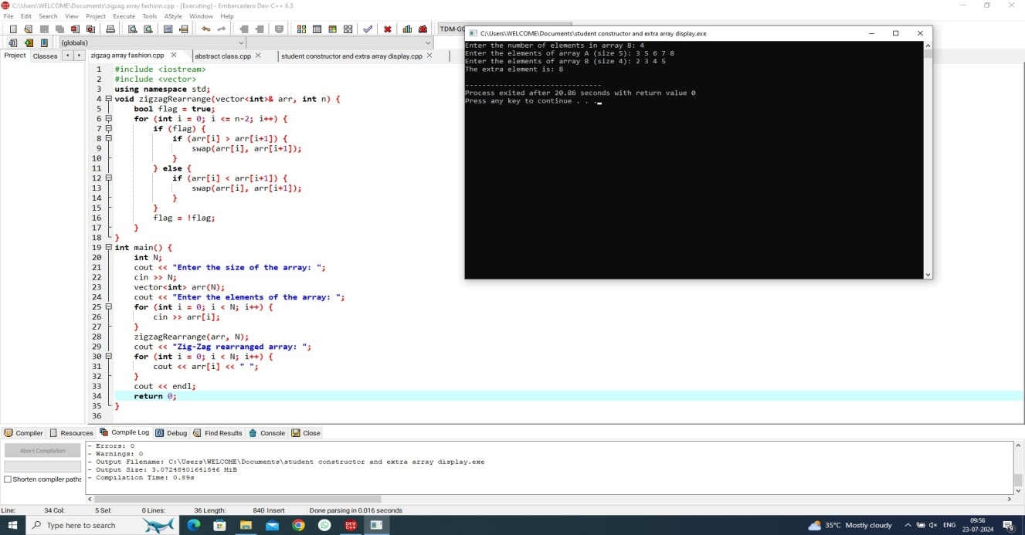

Given an array of distinct elements of size N, the task is to rearrange the elements of the array in a zig-zag fashion so that the converted array should be in the below form: arr[0] < arr[1] > arr[2] < arr[3] > arr[4] < arr[n-2] < arr[n-1] > arr[n].Input: N= 7, arr[] = {4, 3, 7, 8, 6, 2, 1}Output: arr[] = {3, 7, 4, 8, 2, 6, 1)Explanation: The given array is in zig-zag pattern as we can see 3 <7>4<8>2<6>

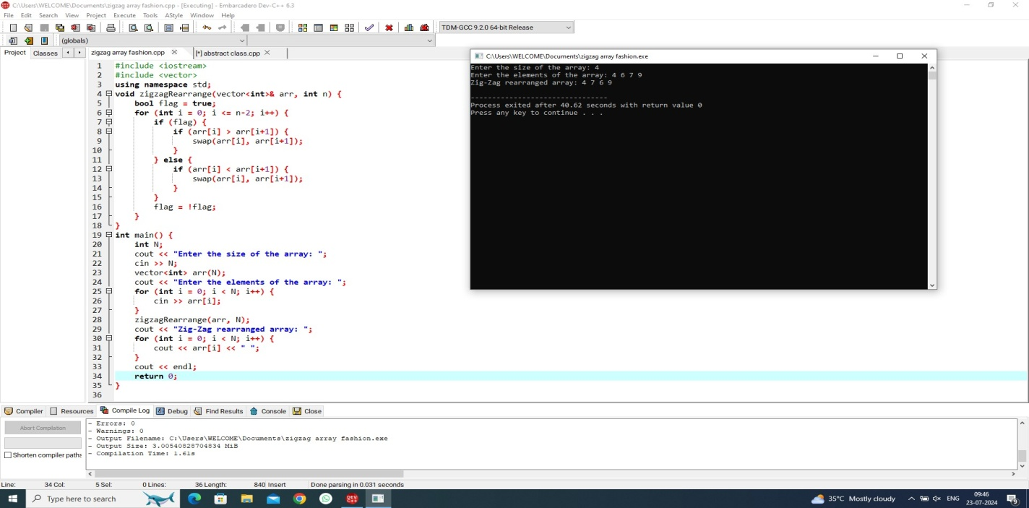

Write a C++ code to find area of square and circle using abstract class and pure virtual function.

Input:

Enter radious of the circle : 5

Enter the length of the suare : 4

Output:

Area of Square : 16

Area of Circle : 78.5

